**Advanced Technological Institute – Kurunegala**

www.hndit.com

Sri Lanka Institute of Advanced Technological Education

**IT 4103 – Web Programming**

Higher National Diploma Information Technology -2013, Semester 2

**Tutorial 2- CSS Practical Tutorial**

Reference - <http://www.w3schools.com/css/default.asp>

Identify the styles apply in following examples and write down codes to implement it.

Q18)

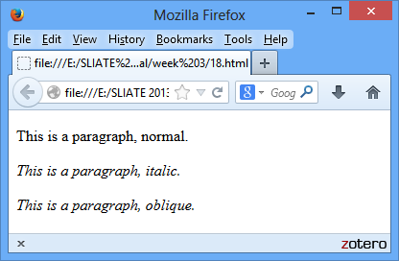

Q19)

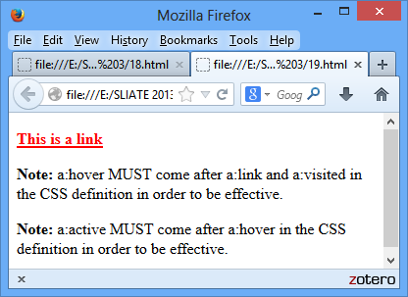

www.hndit.com

Q20)

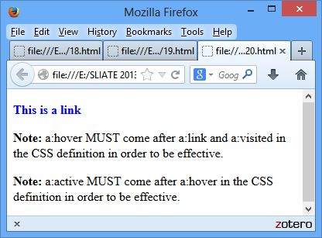

Q21)

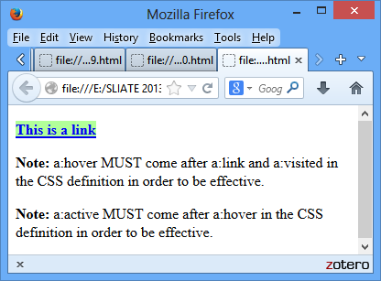

www.hndit.com

Q22)

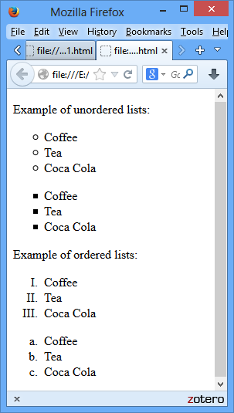

Q23)

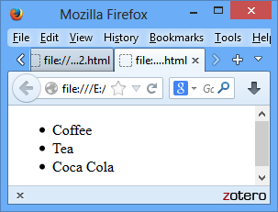

Q24)

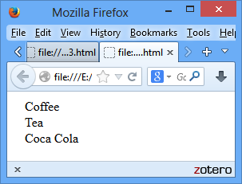

www.hndit.com

Q25)

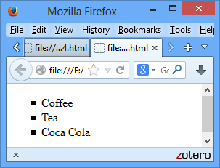

Q26)

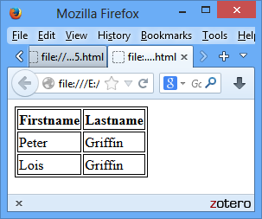

Q27)

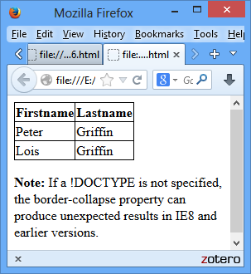

www.hndit.com

Q28)

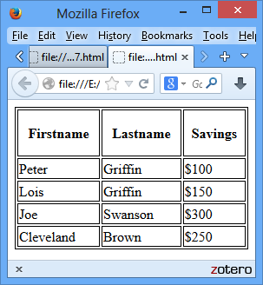

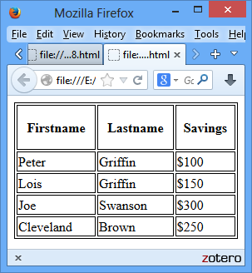

Q29)

www.hndit.com

Q30)

